JEFFREY M. GARCIA DDS, MS
KINAN M. AL-BITAR DDS, MS

Date: ________________

Patient Name: ___________________________ Patient Phone Number: _________________
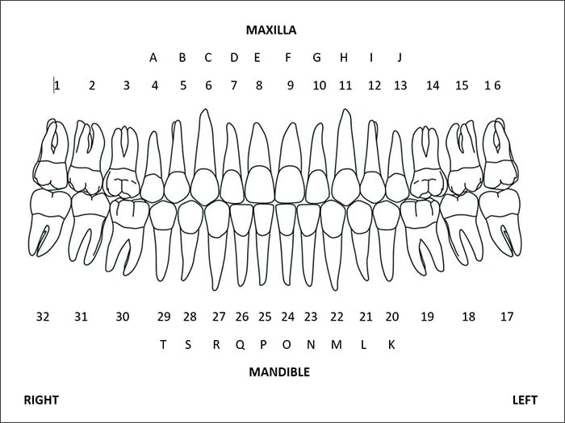
Reason for Referral:

Full Mouth Examination__________
Recession_____________________
Implant_______________________
Extractions____________________
Recession____________________
Crown Lengthening____________
Ortho-Perio__________________
Other_______________________

History of Periodontal Therapy: __________________________________________________________________________________________________________________________________________________________________________________________________________________________________________
Restorative Considerations: ____________________________________________________________________________________________________________________________________________________________

Radiographs: Full Mouth Panoramic Bite Wings Periapical CBCT
Additional Comments Relevant to this referral:

__________________________________________________________________________________________________________________________________________________________________________________________________________________________________________
Referring Doctor: ________________________________

WAUKESHA
2316 N. GRANDVIEW BLVD.
WAUKESHA, WI 53188
262-547-1877
MUKWONAGO
400 BAY VIEW RD STE K
MUKWONAGO, WI 53149
262-363-1933

